DR. AMBEDKAR COLLEGE, DEEKSHABHOOMI, NAGPUR,

DEPARTMENT OF LAW
ACADEMIC SESSION 2022-23
NAME OF PROGRAMME: | ALUMNI MEET 2022 and  LAWMENS CRICKET 2022
DATE AND DAY: | 5th and 6th November 2022
TIME: | 11:00 AM
VENUE: | Department of Law
PROGRAMME SUPERVISOR: | Prof. Dr. Mrs. H.V. Menon

Department of Law, Dr. Ambedkar College Deekshabhoomi, Nagpur organized an Alumni Meet on 05th November 2022 at 11.00 am. Alumni from the batch of 2006 to 2020 were remarkably present in the meet. Students of LLB 3 Years and 5 years were also present. On this occasion of Alumni meet, Department of law, inaugurated a literature section named ‘The Book Hangout’ for their students in the Department’s Library. Over 332 books in the genre of Biographies, Mystery, Political Tragedies and many more for the cause were donated by the Alumni of the Department. The welcome address for the event was delivered by Principal of the College, Dr. B.A. Mehere and The Book Hangout was inaugurated by prominent alumni, Hon’ble Judge, Shri. Uday Patil., Senior Judge, Hingoli. Shri. Uday Patil.
Other prominent alumni of the department, Shri. Nitin Gautam, Shri. Arvind Giri, Shri. Ajay Dhawle and Mrs. Ketaki Kane shared the dais. These alumni while interacting with the students, shared their respective expertise knowledge, life experiences and the old college memories of the department. Law Students of the different semesters eagerly waited for their turn to ask questions to the alumni. The alumni of different batches also visited the Department and had good times rejuvenating the memories of the Department. The program was attended by all the regular and visiting faculty members. The program was conducted by Harsh Ghate.

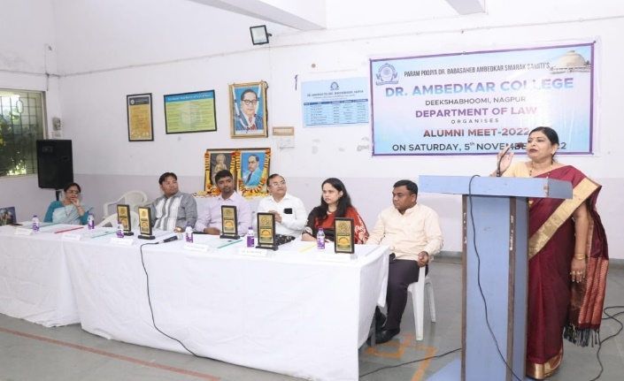 | 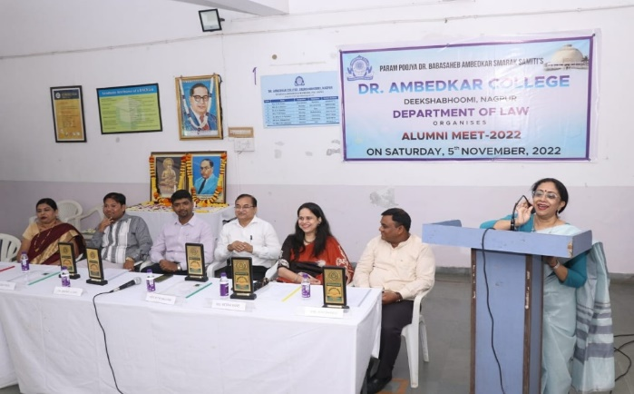
Principal, Dr. B.A.Mehere and Head of Department, Prof. Dr. H.V. Menon addressing the gathering in the Alumni Event.

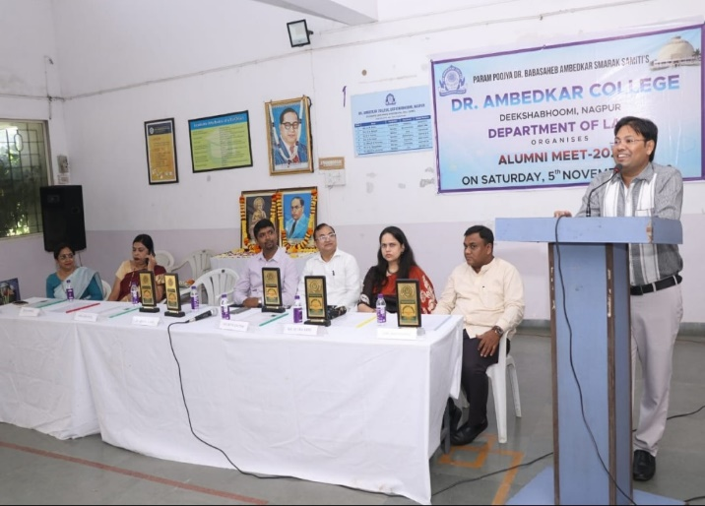
Hon’ble Judge, Shri Uday Patil, one of the prominent Alumni addressing the gathering.

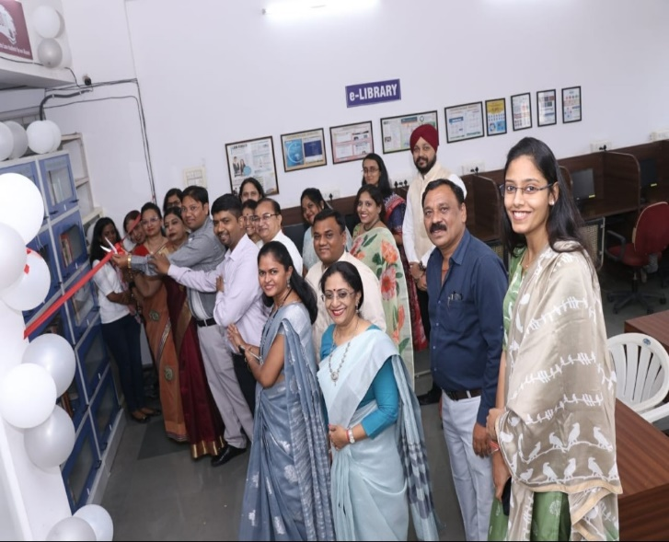
Inauguration of “The Book Hangout” in the Library of Department of Law

On the same day, Department of Law, inaugurated Lawmen's Cricket Tournament on 5th November 2022, at the sports ground of the college at the hands of renowned lawyer Adv. Shrirang Bhandarkar. In all 8 teams participated in these two days event out of which 4 teams are from the college and 4 Alumni teams. Total 8 matches were conducted on first day. Principal of the college Dr. Mrs. B.A. Mehere, Vice-Principal Dr. A.P. Joshi, Head of the Department, Dr. Mrs. H.V. Menon, Mr. Vikrant Senad, faculty members of Law Department, alumni and a number of students attended the function. Speaking on the occasion Adv. Shrirang Bhandarkar motivated the students and was delighted with the unique concept of conducting such event with the alumni of the college as it provides a platform for the students to interact with the alumni.
The Semi Finals and Finale of the Lawmens Cricket Tournament was conducted on 6th November 2022. Award ceremony was graced by the Chief Guest Dr. S.M.Rajan, Director CICL and Founding Alumnus and Guest of Honor Adv. Ranjan Deshpande. Dr.Rajan while interacting with the students shared his recollections about his college days. He emphasized that games and sports are an integral part of a student’s life and it should be played to enjoy the health and vigour of life.
All the teams played excellently well. The winners were felicitated for their commendable efforts with trophies and cash prizes. Team Ruscle Muscle (Team Alumni) beat the Mavericks (Student Team) in the finale and claimed the trophy. The second runner up were Team Super Kings, Man of the Series title was bagged by Sahil Mohammed, best batsman (male)– Sanket Asre, Best batsman (female)- Vasundhara Thakre, Best bowler(male) – Shivraj Nirmal, best bowler (female) – Anushka Chitaley.
Head of the Department, Dr. (Prof.) H.V. Menon delivered the Vote of Thanks and ensured that every person’s efforts were recognized.

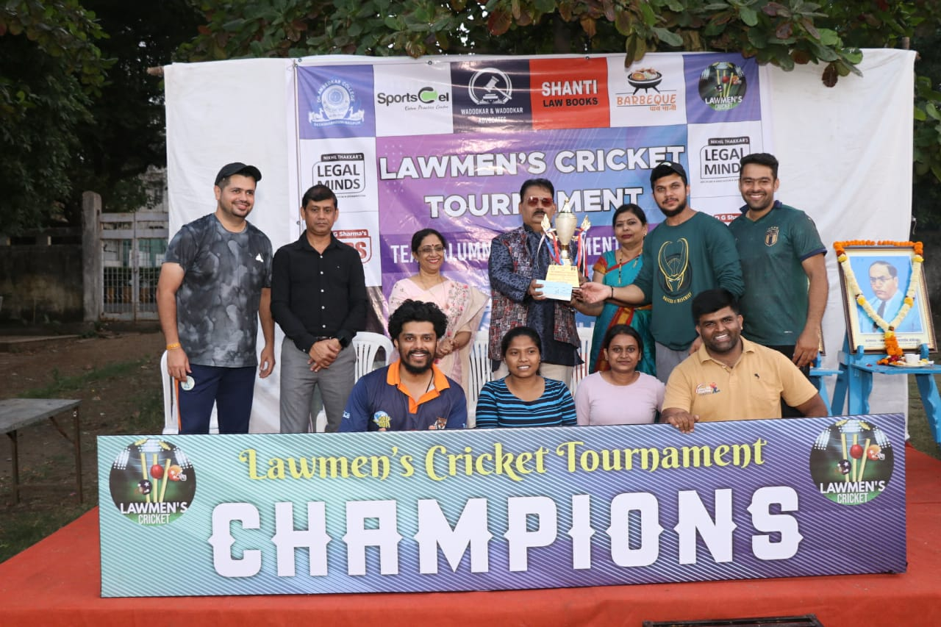
Cheif Guest, Dr. S.M. Rajan, Guest of Honour, Adv. Ranjan Deshpande, Principal Dr. B.A. Mehere and HOD, Prof. Dr. H.V.Menon with the Winner team, ‘Russel Muscel’

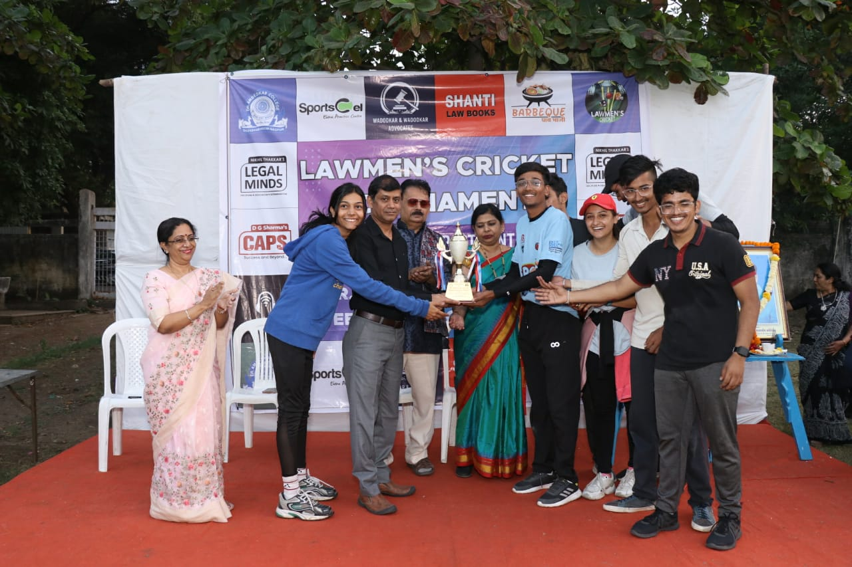
Cheif Guest, Dr. S.M. Rajan, Guest of Honour, Adv. Ranjan Deshpande, Principal Dr. B.A. Mehere and HOD, Prof. Dr. H.V.Menon with the Second Runner team ‘Mavericks’

